**WAGNER—**Letter K – Fermata

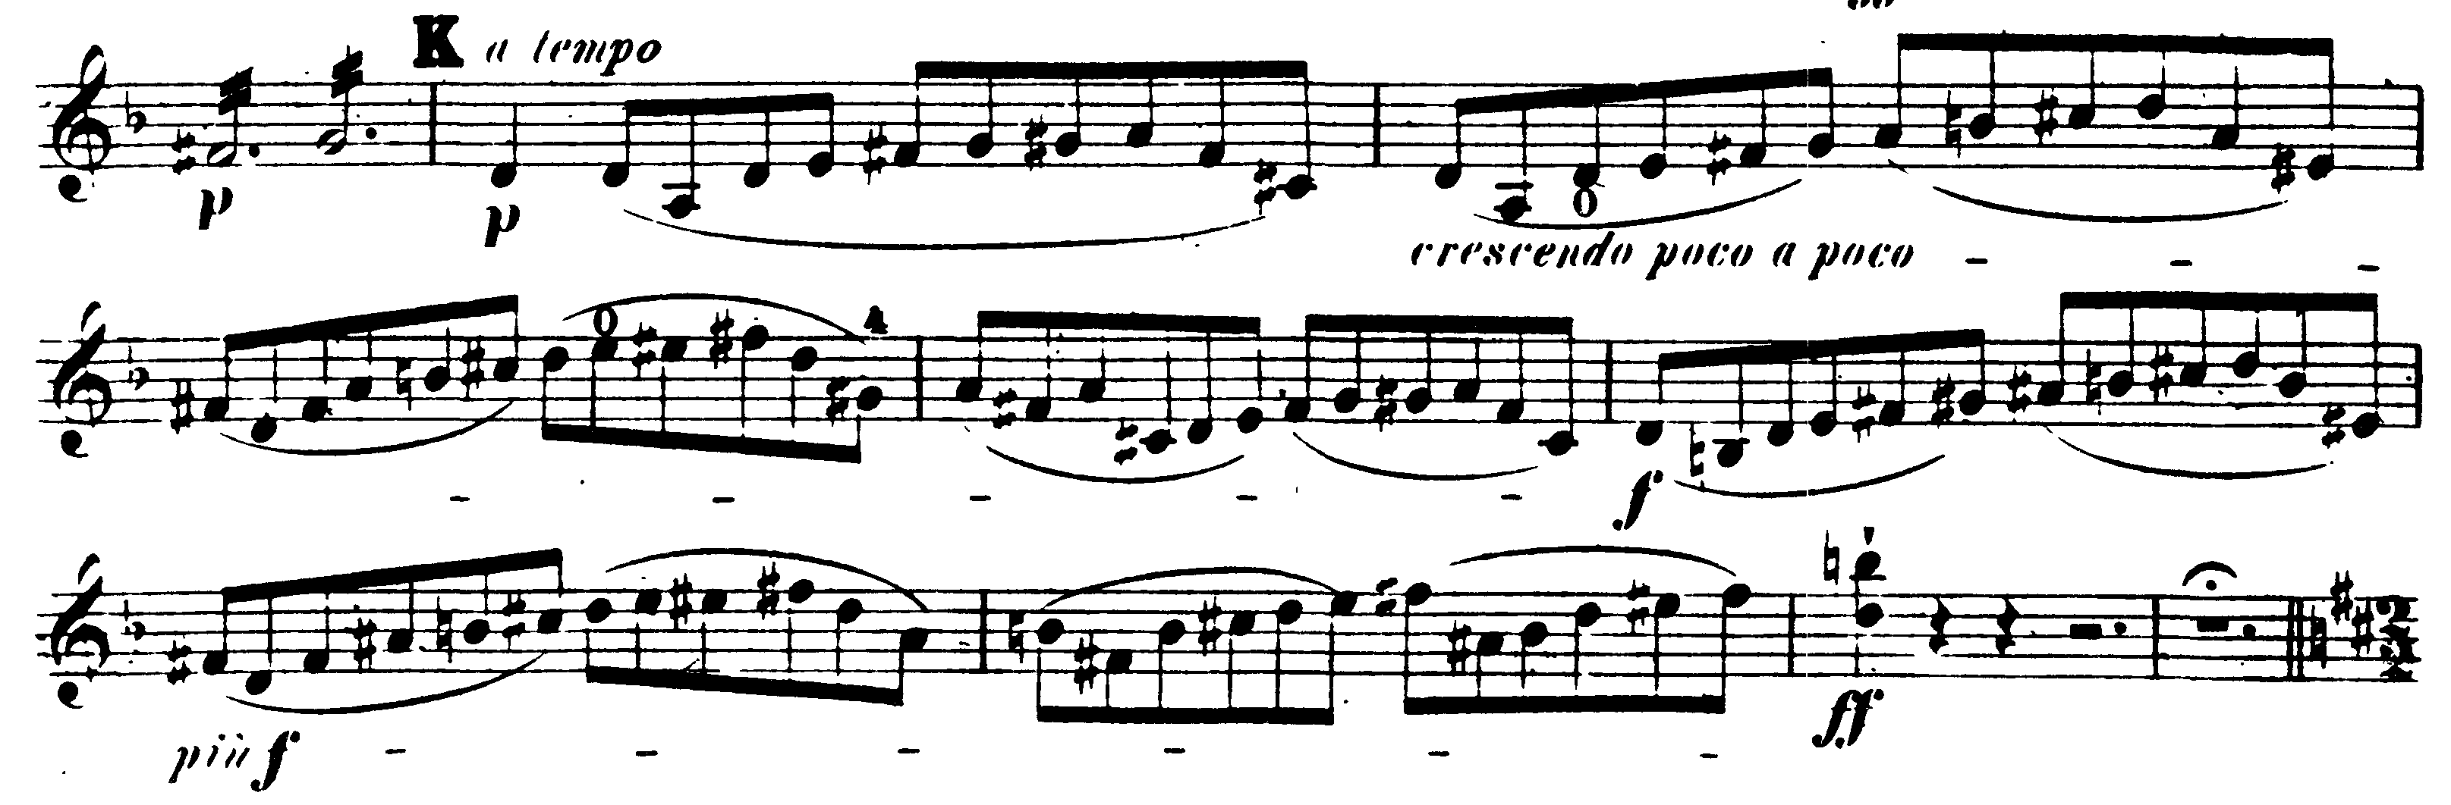

17 before 6/4 meter – 6/4 meter

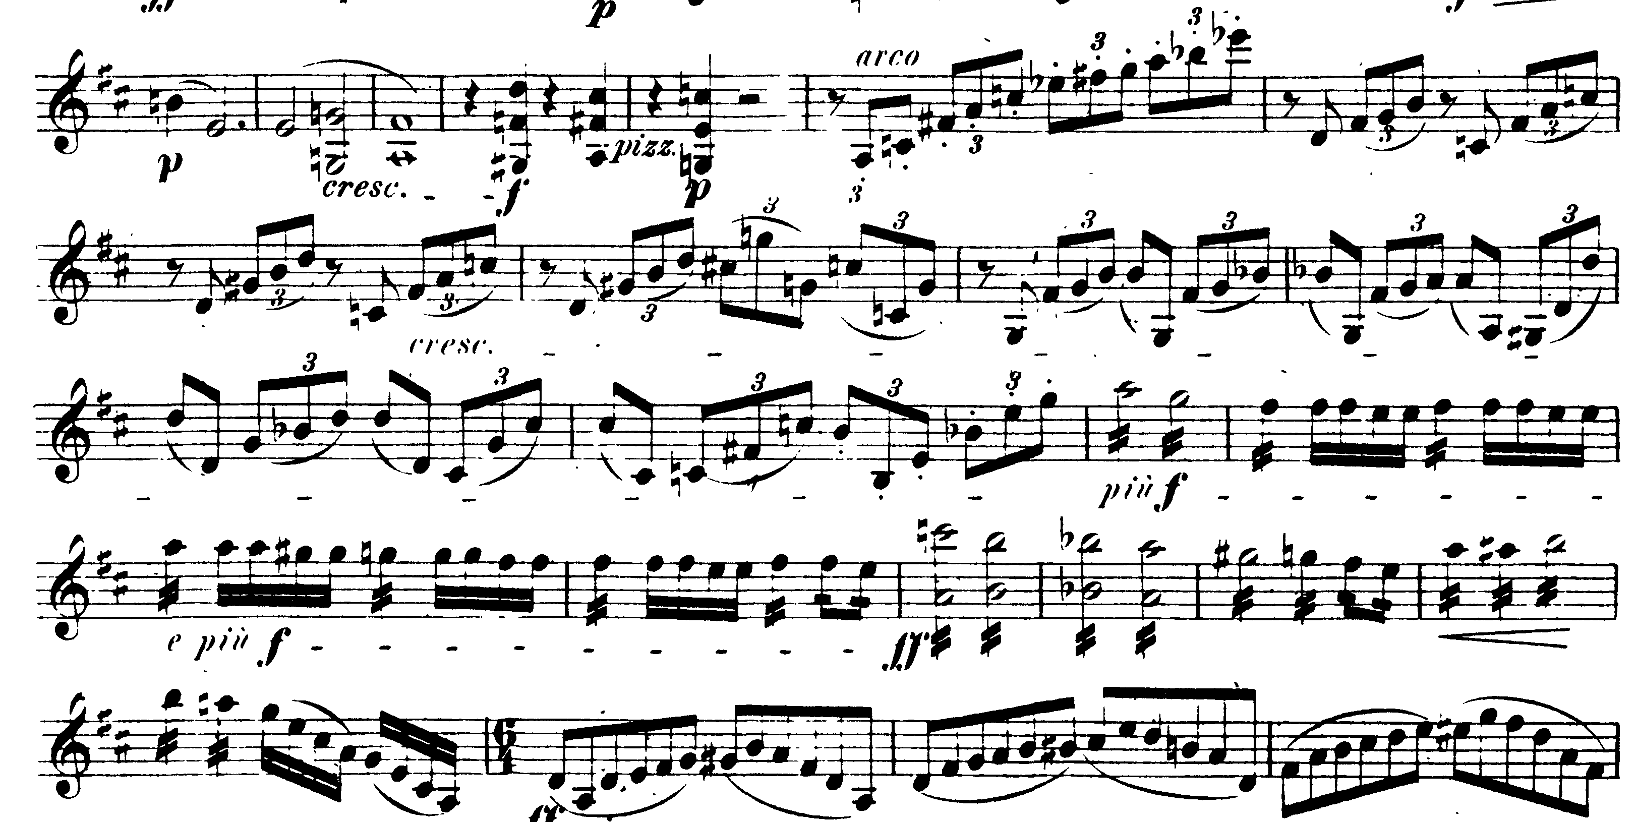

**TCHAIKOVSKY—**Mvt IV: Allegro vivace – D

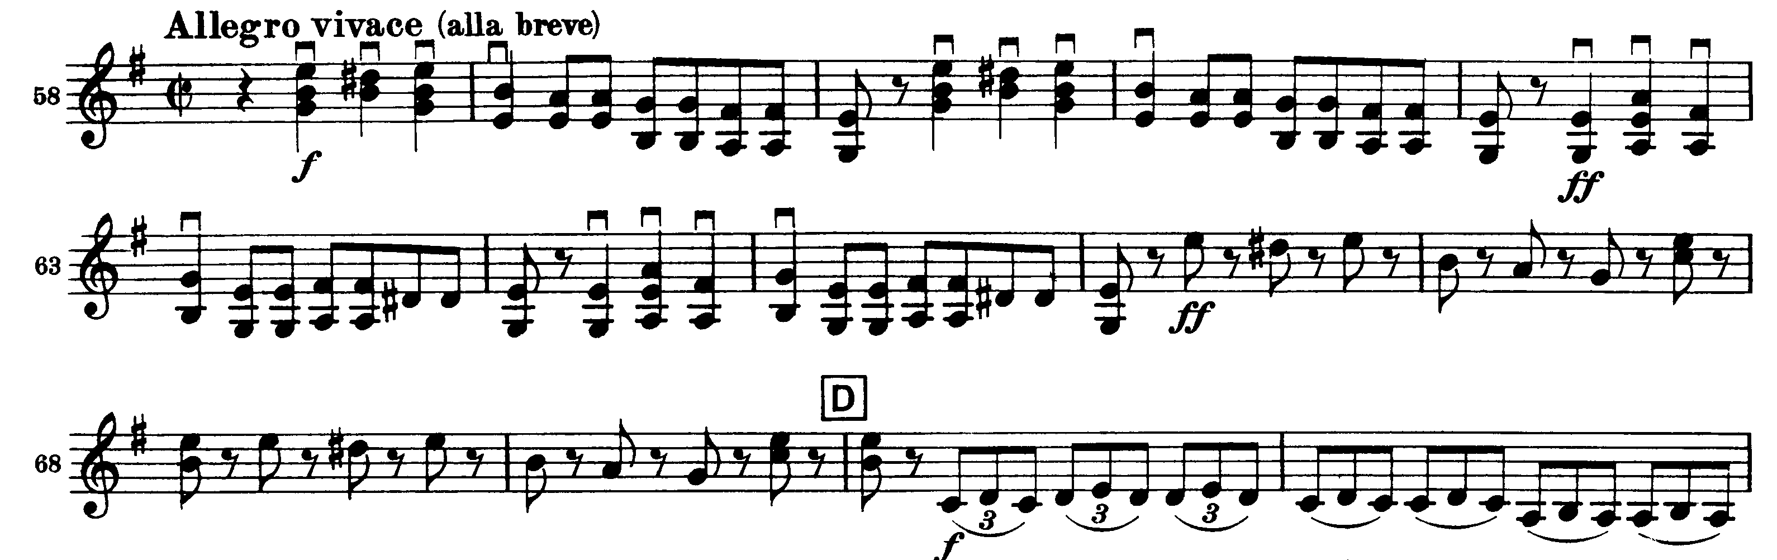

Mvt IV: Presto – Molto meno mosso

